July 12, 2023

Zoning Board of Appeals
Topsfield Town Hall
8 West Common St.
Topsfield, MA 01983
Attn: Robert Moriarty, Chairman
RE: Connemara Farm

Dear Mr. Moriarty, and the Board:

First, my gratitude to you all for your energy and extended attention to this matter. I must add my own comments:
1. The noise was very stressful. A nasty experience.
2. Decibels don't tell the whole story. The nature of the noise is at least as important in producing stress*.
3. This is not just a quality of life issue, it is a health hazard. The harmful health consequences of such noise have been measured by major organizations and the data is available*.
4. There are practical solutions to this problem.

Thank you for your attention.

Sincerely,

Robert M. Rose
by USPS and e-mail

*PS- see this link for a good example: https://www.nytimes.com/interactive/2023/06/09/health/noise-exposure-health-impacts.html?unlocked_article_code=I-Sa9yYCTdfGlpA8ufOKx3GU6lhVHpYE1nO36-rncs_so8e5WorEb4I0Ubn8Oia5r-aMLQksBBpppgSpXrX3TeDRi-QInFNn89bgLptLW80xAiMY9vobB-pmA1YmMoz6G2Nn7jLad4xL4aZbt-OpMnSTHUXEhziVf2K_epy2uj6hstuKkC1FgqxdMI2brvTkJoW8RAgyIZaKpcTwuW0zb7bSAMV4uIlFrV6HRYLHN60Y0RWjE5g8wQtjTkRCOgrg2uA-WW8XYZ4Cbspyxs3NvYtU0JlWXvGxi7ZROxOsCPOHXWsLExur1gEqc6eb2mSpAmkzkApWmyAmYBOPNqPw1RvYvGj5sJFyWDxZXqNvX-L-7WMJOm8&smid=em-share
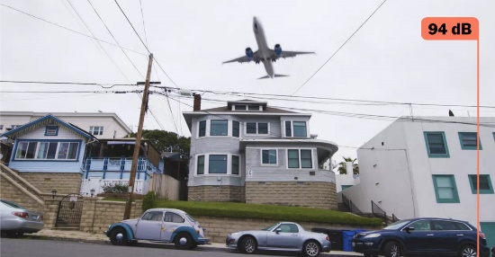 | Noise Could Take Years Off Your Life. Here’s How.  We used a professional sound meter to measure the din of daily life and talked to scientists about the health risks it can pose.  www.nytimes.com

