Time to start counting….. 1, 2, 3, 4, 5, 6, 7, 8, 9, 10, 11, 12!
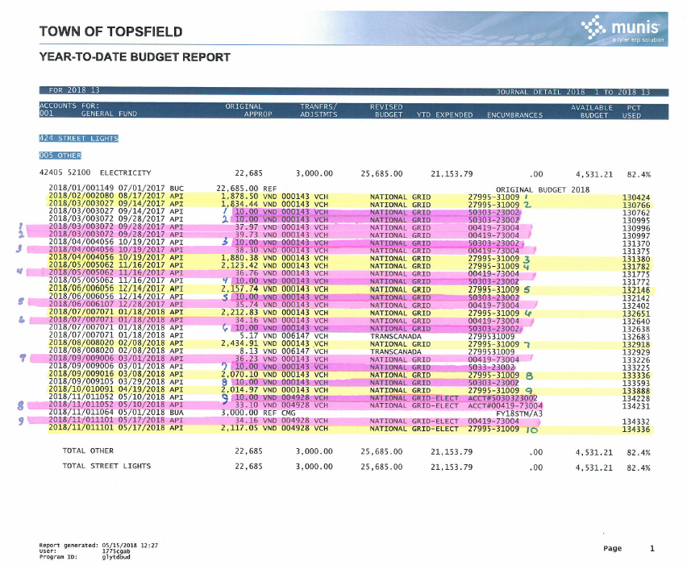
Monthly bills include: gas, electric, phone, cable, cell phone, VNA services, cleaning company, etc.
Quarterly bills include: water

Monthly, Quarterly, Annually… make sure you pay your bills within the fiscal year!

