NATIONAL GRID – gas
Vendor # = 4927
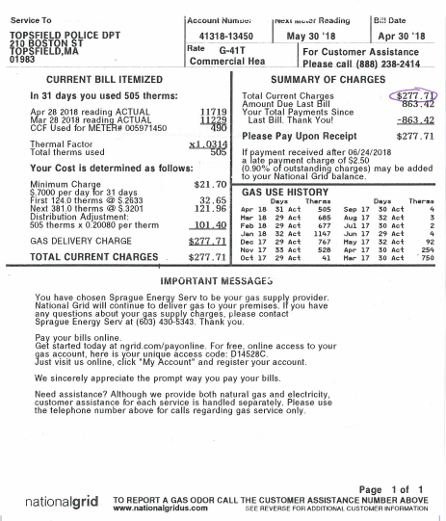
Please note the vendor #, invoice #, invoice date, and description (customer # or acct #)
