NATIONAL GRID – electric
Vendor # = 4928
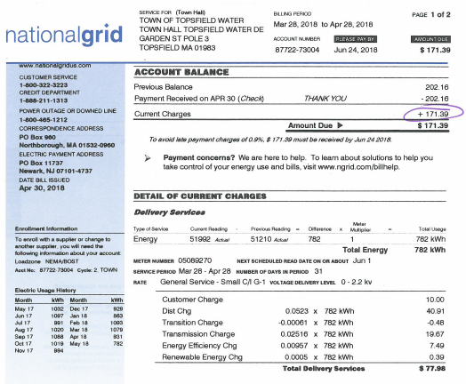
Please note the vendor #, invoice #, invoice date and description (customer # or acct #)
