TOWN OF TOPSFIELD

Historic Commission
8 West Common Street, Topsfield, Massachusetts 01983

October 18, 2019

Legal Notice
Topsfield Historic Commission

The Topsfield Historic Commission will hold a public hearing in Town Hall on October 29, 2019 at 7:45 pm to consider the application for review under the Demolition Delay By-Law, Chapter XXVI for the removal of structures located at 41 Cross Street, a/k/a Meredith Farm, Topsfield, MA 01983.

The application documents can be reviewed at Town Hall.

Thank you,
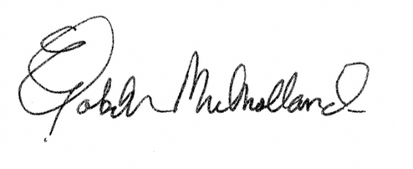
Elizabeth Mulholland, Chair
Topsfield Historic Commission
Town Hall
Topsfield, MA 01983
978-887-8215

